Steps to install Playwright
npm init playwright@latest
npx playwright test Amazon.spec.js = To execute particular test case

For screenshot, video, headless mode make these changes in playwright.config.js file.
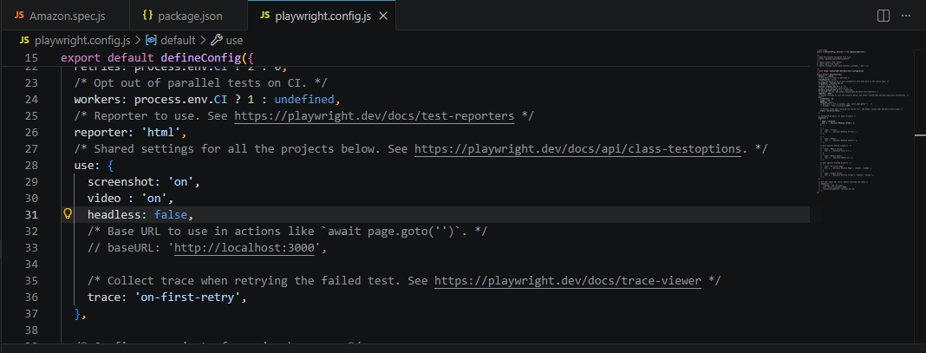

For Single worker make changes in fullyParallel
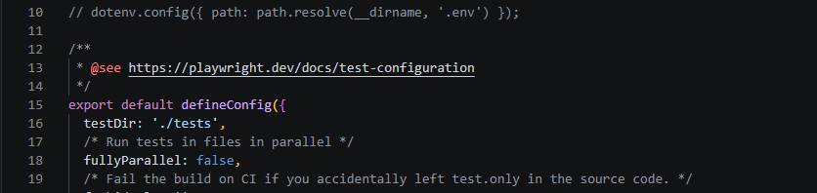

Different Locators in Playwright:
- getByRole () to locate by explicit and implicit accessibility attributes.
- getByText () to locate by text content.
- getByLabel () to locate a form control by associated label's text.
- getByPlaceholder () to locate an input by placeholder.
- getByAltText () to locate an element, usually image, by its text alternative.
- getByTitle () to locate an element by its title attribute.
- getByTestId () to locate an element based on its data-testid attribute (other attributes can be configured).

npx playwright test
Runs the end-to-end tests.
npx playwright test --ui
Starts the interactive UI mode.
npx playwright test --project=chromium
Runs the tests only on Desktop Chrome.
npx playwright test example
Runs the tests in a specific file.
npx playwright test --debug
Runs the tests in debug mode.
npx playwright codegen
Auto generate tests with Codegen.
We suggest that you begin by typing:
npx playwright test
And check out the following files:
- .\tests\example.spec.js - Example end-to-end test
- .\playwright.config.js - Playwright Test configuration

Running Tests by Tag :
Playwright provides the --grep and --grep-invert CLI options to filter tests.
Run only @smoke tests:
npx playwright test --grep "@smoke"
Run tests with either @smoke or @login:
npx playwright test --grep "@smoke|@login"
Run tests with both tags (AND condition):
npx playwright test --grep "(?=.*@smoke)(?=.*@login)"
Exclude a tag:
npx playwright test --grep-invert "@slow"

Annotations
- test.skip() marks the test as irrelevant. Playwright does not run such a test. Use this annotation when the test is not applicable in some configuration.
- test.fail() marks the test as failing. Playwright will run this test and ensure it does indeed fail. If the test does not fail, Playwright will complain.
- test.fixme() marks the test as failing. Playwright will not run this test, as opposed to the fail annotation. Use fixme when running the test is slow or crashes.
- test.slow() marks the test as slow and triples the test timeout.
- test.only() these are the focused test, it will execute that test case only.

Allure Report commands:
npm install -D allure-playwright
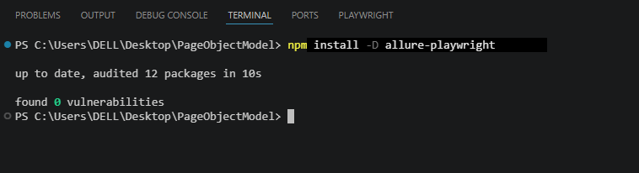

npm install -g allure-commandline
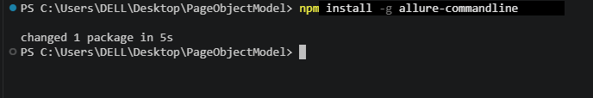

After command “npx playwright test Login.spec.js” allure-results appears left side.
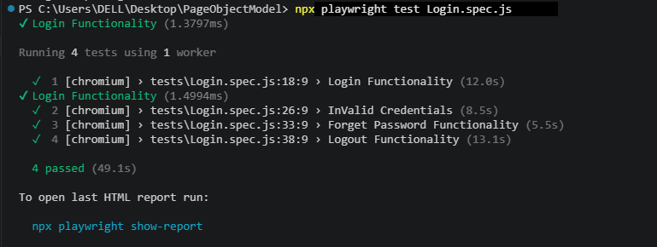

To execute current tests report “allure generate ./allure-results –clean” command is used.
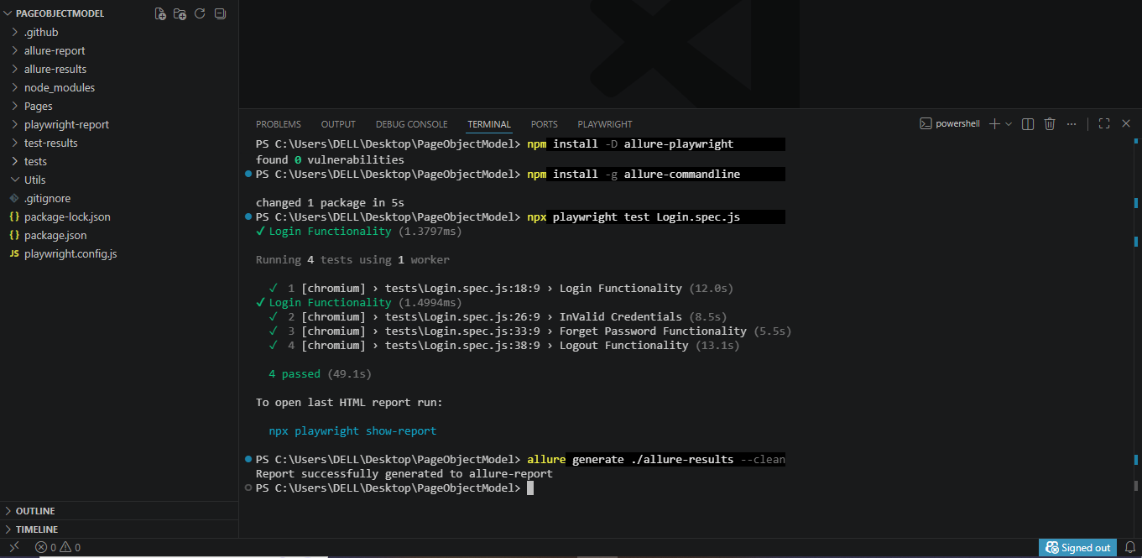

To generate Report “allure open” command is used
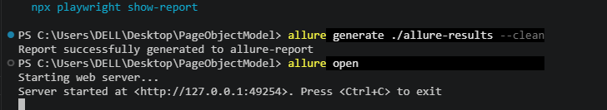

Report Generated
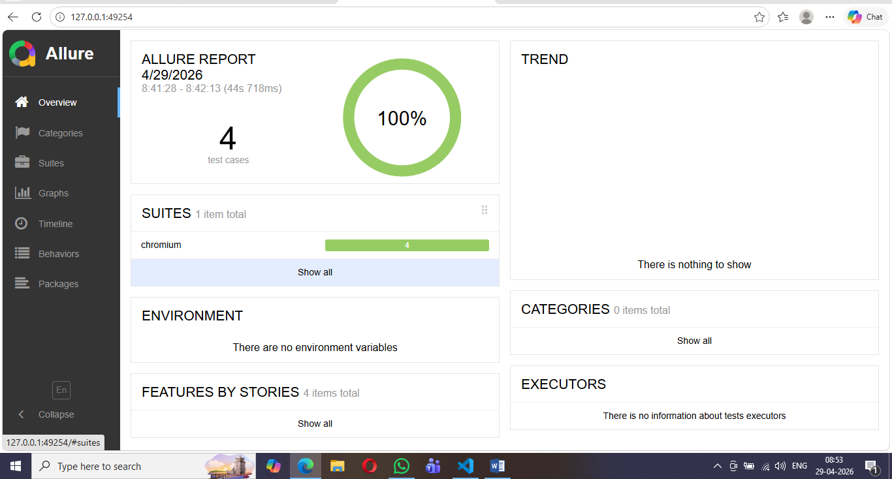
Create JSON File Commands:
Step 1: Install JSON Server
Make sure you have Node.js and npm installed. Then install JSON Server globally.
npm install -g json-server

Step 2: Create a JSON Data File
Create a file named db.json in your project root. This will act as your database:
npm install json-server

Step 3: Start the Server
Run the server and watch for changes:
Create a file named db.json in your project root.
Copy the content into json file.
[
{
"id": "1",
"title": "Thriller",
"author": "Michael Jackson"
},
{
"id": "2",
"title": "JSON Server Rocks",
"author": "Jane Smith"
},
{
"id": "ItqNdMXTui0",
"title": "Dats Structre",
"author": "Gauri"
}
]

This will act as your database.
json-server --watch db.json --port 3000

This will generate RESTful endpoints automatically:
GET /users – List all users
GET /users/:id – Get a user by ID
POST /users – Add a new user
PUT /users/:id – Update a user
DELETE /users/:id – Remove a user.
Cucumber Commands :
npm init –y
npm install playwright @playwright/test --save-dev
npm install @cucumber/cucumber @cucumber/pretty-formatter --save-dev
npm install typescript ts-node --save-dev
npx playwright install
npx tsc –init
npx cucumber-js (To get Step Definition File)

Install the Cucumber/Gherkin Extension
- Open VS Code.
- Go to the Extensions panel (Ctrl+Shift+X).
- Search for Cucumber (Gherkin) Full Support or Cucumber for VS Code.

Install it.
Commands given by Sir :
npm install @playwright/test
npm install @cucumber/cucumber
npm install ts-node typescript --save-dev
npm init play
npm init playwright@latest

Git commands:
git clone
git init
git checkout –b “New_Branch123”
git add.

git status
git commit –m “Test case updated”
git push
git branch –a
git checkout

git status
git add
git restore –staged filename (to take files back)

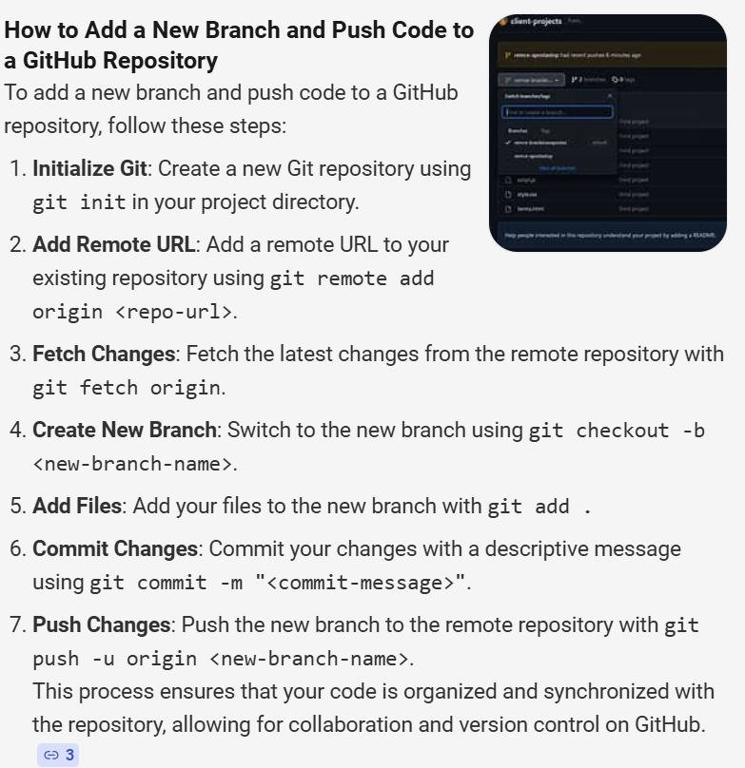

editor.quickSuggestions

